**CIS-350  
Infrastructure Technologies**

**Lab 2 Report**

**Student Name**: **_Spencer Kerber__________________________**

1. Insert *Lab2_Tree* file from p. 8 of the Lab 2 instructions into the space provided or use the *Alt-PrtScr* keys to capture the screen output (window) from command *TYPE Lab2_Tree* on p. 8 and paste that window here.

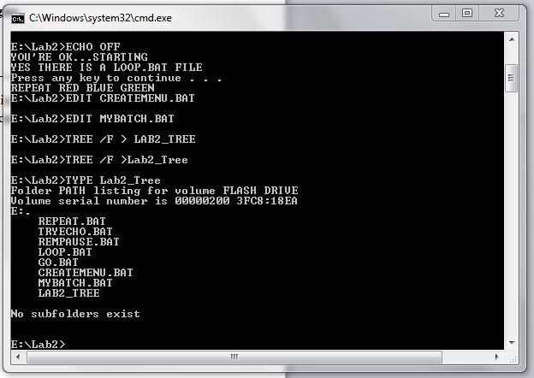

1. Assume that the system prompt displays "C:\>", i.e., your current directory and current drive are the root directory and C drive, respectively. Write a batch file below that will include commands to:
2. prevent all commands from displaying on the screen

ECHO OFF

1. display the following message "A simple batch file"

ECHO A simple batch file

1. display the directory hierarchy of the C disk

tree \

1. display the directory hierarchy of the C disk with all files

tree c:\

1. create sub directory named *CLASSES* in the root directory

TREE c/ > CLASSES

1. erase subdirectory *BOOK* from the root directory

rmdir /c \BOOK

1. copy file *Go.bat* to directory *CLASSES*

*COPY Go.bat C:\CLASSES*

1. pause the screen

PAUSE

1. display the directory and pipe it through the *MORE* command

tree c:\ | MORE

1. sort data in the ascending order coming from file *Letter3* and route the output to file *Letter3_Sorted*

SORT Letter3 | Letter3_Sorted

The batch file, commands (a) through (j):

1. Describe step by step what a file named MYBATCH does.

**ECHO OFF**

Suppress the command echoing type

**REM STARTING BATCH FILE**

Documenting starting the batch file

**TREE /F**

Display the directory path of F

**PAUSE**

Stop execution of batch file MYBATCH

**DIR**

Display a list of director files

**PAUSE**

Stop execution of batch file MYBATCH

**MD JOE MARY STACY**

Create new directories for Joe, Mary, and Stacy

**TREE /F**

Display the directory paths

**PAUSE**

Stops execution of batch file

**COPY *.BAT E:\LAB2\STACY**

Copies all .bat type files to Stacy

**TREE /F**

Displays the directory paths

**PAUSE**

Stops the execution of batch file

**CD STACY**

Changes the subdirectory to Stacy

**ERASE *.BAT**

Deletes all .bat type files

**PAUSE**

Stops the execution of batch file

**CD ..**

Changes directory by moving up one

**TREE /F**

Displays the directory paths

**PAUSE**

Stops the execution of batch file

**RD JOE MARY STACY**

Removes directories Joe, Mary, and Stacy

**TREE /F**

Displays the directory paths

**PAUSE**

Stops the execution of batch file

**REM CLOSING BATCH FILE** Displays CLOSING BATCH FILE

The ECHO OFF command … REM displays STARTING BATCH FILE on the screen. TREE /F displays the …

Directory Paths

1. Optional. Briefly describe any issues with the lab. Point me to the specific pages and suggest changes. Thanks.